**Class:** Final Year (Computer Science and Engineering)

**Year:** 2022-23 **Semester:** 1

**Course:** High Performance Computing Lab

**Practical No. 2**

**Exam Seat No:**

1. 2019BTECS00038 – Sadaf Najeem Mulla

**Title of practical:**

Vector Scalar Addition and Vector Vector Addition.

**Problem Statement 1:** Vector Scalar Addition

**Screenshots:**

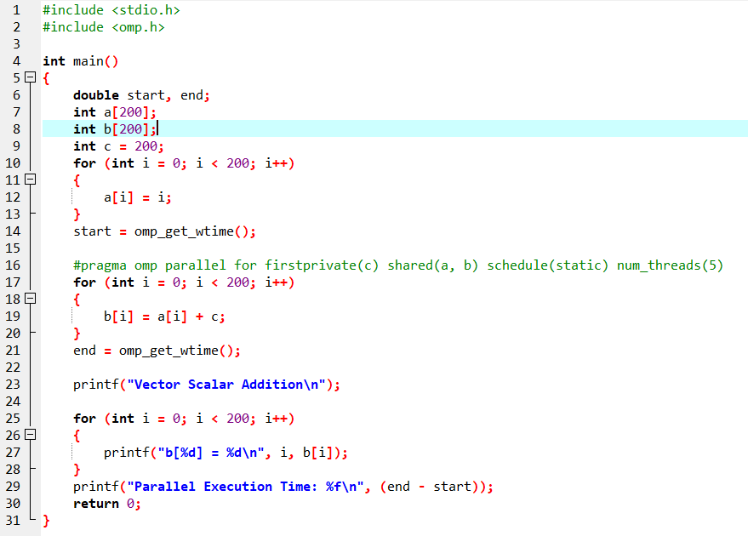

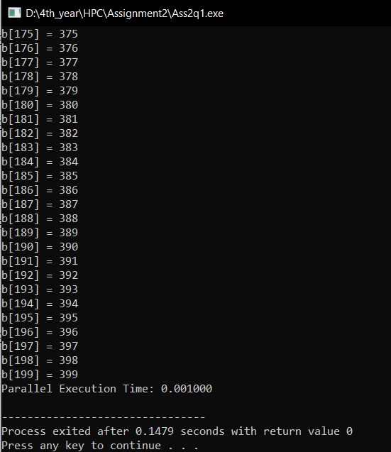

**Information :**

Pragma around for loops is built into openMP because this ‘repeat N times” pattern occurs so frequently in a great deal of code. This simplicity can be deceiving, however– this particular example lends itself well to having the threads share data, but other types of problems are not this simple. This type of data decomposition example is sometimes called embarassingly parallel, because each thread can read and update data that no other thread should ever touch.

**Problem Statement 2:** Vector Vector Addition

**Screenshots:**

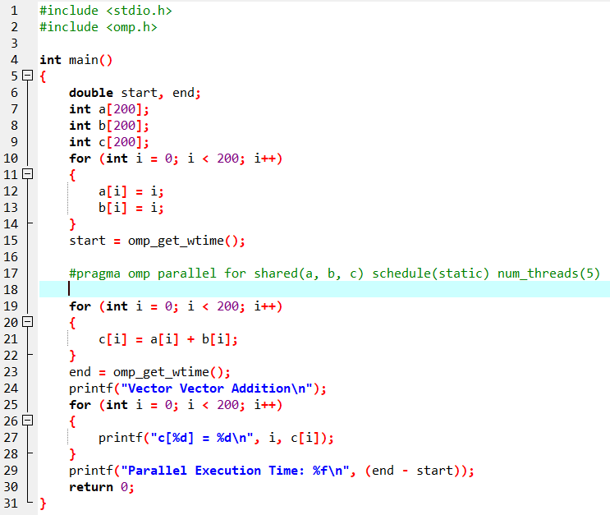

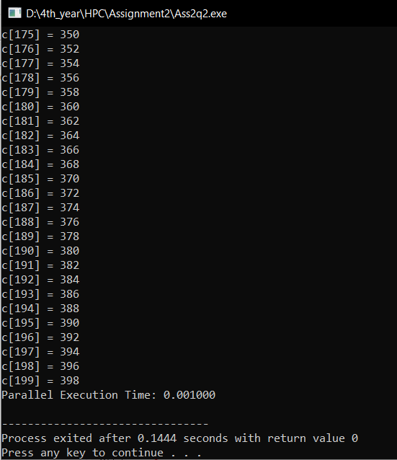

**Information :**

Pragma around for loops is built into openMP because this ‘repeat N times” pattern occurs so frequently in a great deal of code. This simplicity can be deceiving, however– this particular example lends itself well to having the threads share data, but other types of problems are not this simple. This type of data decomposition example is sometimes called embarassingly parallel, because each thread can read and update data that no other thread should ever touch.

**Github Link:** [**https://github.com/sadafmulla/HPC_LAB/tree/main/Assignment2**](https://github.com/sadafmulla/HPC_LAB/tree/main/Assignment2)